**Visvesvaraya Technological University**

**Belagavi, Karnataka-590018**

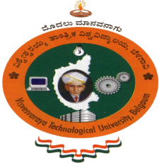

Report on

**“AICET Activity point Program”**

Submitted for partial fulfillment of the requirement for the award of the degree of

**Bachelor of Engineering**

**in**

**Electrical and Electronics Engineering**

**Submitted by**

Madhu Gowda h k-4AD18EE015



**Department of Electrical and Electronics Engineering**

**ATME College of Engineering**

**13th K.M stone, Mysuru-Kanakapura- Bengaluru road, Mysuru-570028**

**2021-2022**

**ATME College of Engineering, Mysuru-570028**

|  |  |  |
| --- | --- | --- |
| Name | of Student | MADHU GOWDA H K |
| USN of Student | | 4AD18EE015 |
| Department | | Electrical and Electronics Engineering |
| Entry | to Program | Regular |
| Activity Points | | 50-Regular |
| Titles of Activity Under Taken | | * Eye pledge * Creating awareness about eye donation |
| Places of Activity | | * Mysore |
| Dates | of Activity | 24-06-2022 to 30-06-2022 |
| Number Of Weeks or Hours involved | | 80 Hours |

**REPORT ON AICTE ACTIVITYPOINT**

Activity Point Earned

**TABLE OF CONTENT**

|  |  |  |
| --- | --- | --- |
| **Sl. Number** | **Title** | **Page Number** |
| **1** | **EYE PLEDGE**   1. Executive Summary or Abstract Introduction | 04 |
| **2** | Conduction of activity and photographs | 05-06 |
| **3** | Conclusion and outcome | 06 |
| **4** | Certificates | 07 |

**CREATING AWARENESS ABOUT EYE DONATION TO PEOPLE AROUND US**

**Objective:**

1. Create public awareness
2. Eye donation directly gives vision to another human being
3. Let someone see the beauty through your eyes

**Description:**

Our activity was about **eye donation** , the eye donation camp was organized by “LIONS CLUB -SMARTCITY” Mysore it was collabed with JSS Hospital Mysore to spread the awareness about eye donation .

We took initiate to create awareness among people around us .

In most of the cases donating eye can help gifting eye sight to many people.

Some of my friends they took initiate to donate their eyes to blind people , this activity was done to a social cause.

Secretary of lions club-smart city Mysore, Mrs girija s helped us and appreciated the efforts of ATMECE for consistently encouraging the people in the wellness of the society.

Department of Electrical and electronics engineering ,ATMECE Page 4

**Photograph:**

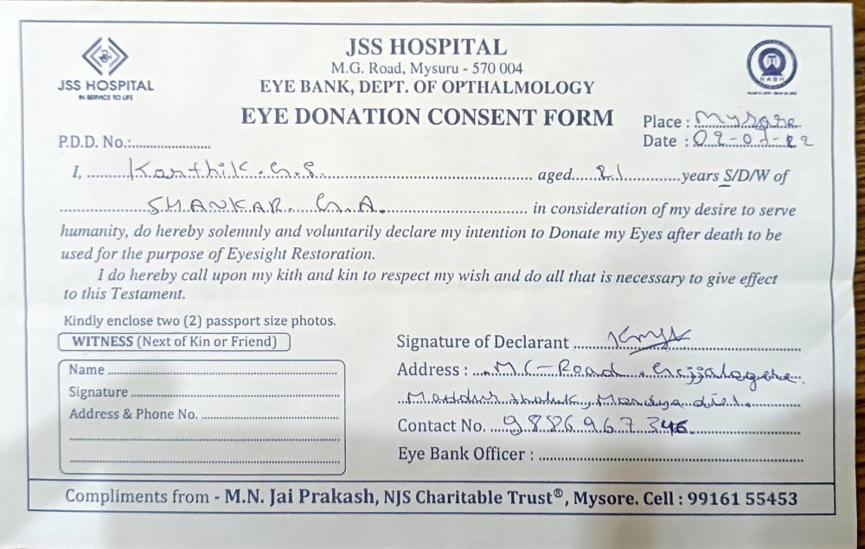

Department of Electrical and electronics engineering , ATMECE Page 5

**My contribution :**

I was able to create the awareness and need of eye donation among my friends. And let them know how our act impact on others life and gives them a new hope of life. And was succeeded in taking there consent by there will to donate there valuable eyes. For someone better days

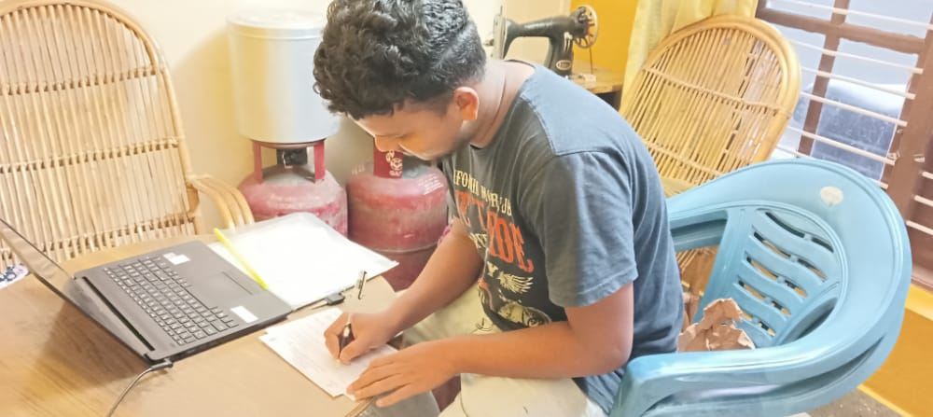

**Conclusion :** The awareness is good in this population, the quantum of people pledged is very low. To make the dream of converting the awareness into pledging and procurement of eyes, the knowledge about eye donation is highly required.

Department of Electrical and electronics engineering ,ATMECE Page 6

**Certificate :**

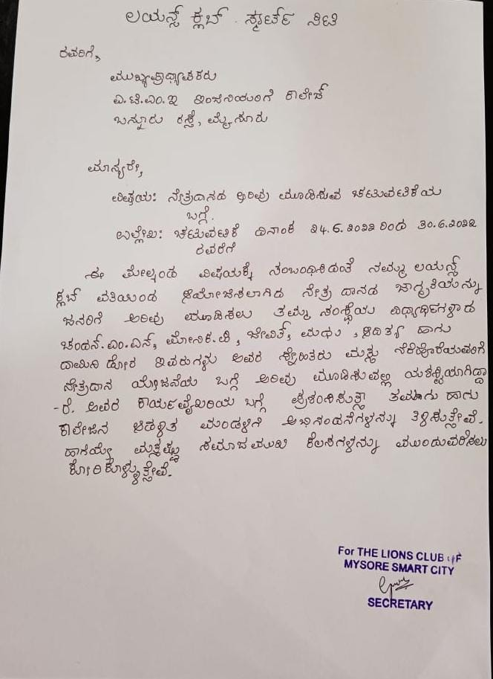Details of Lions club:

Name : Girija S

Ph no: 9731473398

Department of Electrical and electronics engineering , ATMECE Page 7